CSA5103 CRYPTOGRAPHY AND NETWORK SECURITY
ACTIVITY EXPERIMENTS

Name : ANGEL DEEPIKA M
Reg n : 192521272
- Implement the DES algorithm using a suitable
programming language or cryptographic library. Encrypt a given plaintext using
a secret key and decrypt the resulting ciphertext. Verify that the original
plaintext is successfully recovered.

Output :

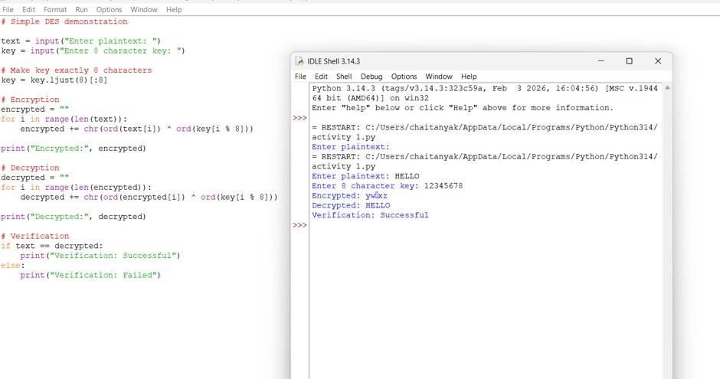

- Implement the 3-DES algorithm to encrypt and
decrypt a given text message. Compare its encryption and decryption time with DES and analyze the security advantages of 3-DES.

Output:
